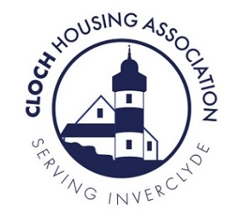
Cloch Housing Association Ltd
Application to Join the Board
This form should be completed by anyone who is interested in the activities of Cloch Housing Association and who wishes to join the Board of Management. Note: to join the Board, you also need to be a member of Cloch and the membership application is enclosed in the pack for those who are not currently a member.
- Name & Address

Landline Telephone
Mobile Phone:

Email:

- Reasons for applying

- Please tell us why you are interested in joining Cloch’s Board

- Having looked at the Board Member Role Description, please say how you think you can contribute to Cloch Board

- Having looked at our Vision and Values, tell us what these might mean to an organisation like Cloch.

- Please describe which part of Cloch’s work you are especially interested in and why

- Other Information

- Are you willing and able to attend training on a regular basis? Yes/No
(note: training for the Board is usually organised in the evenings)

- If you are successful in becoming a member of the Board, what would be your priority during your first year?

- Are you (or have you been) involved in other voluntary work? Yes/No
(If ‘yes’ please provide details)

- Please describe your experience (if any) of serving on the governing body of another organisation

- Current Relationship to Cloch Housing Association

- Are you a member of Cloch Housing Association? Yes/No

- Are you a Cloch tenant or factored owner or Member? Yes/No

- Are you an Oak Tree tenant or customer? Yes/No

- Are you related to anyone who is already a member of either Cloch or Oak Tree’s Boards or to someone who is employed by either Cloch or Oak Tree? Yes/No
If ‘yes’ please give your relative’s name _____________________________
- Are you involved with any business that provides services or is contracted to either Cloch or Oak Tree? Yes/No
If ‘yes’, please give details________________________________________

- Are you employed? Yes/No
If ‘yes’ please give details

Signature:
Date:

Please return to Kristina Thrush, Depute CEO, Cloch Housing Association, 19 Bogle Street, Greenock PA15 1ER or /
e-mail to office@clochhousing.org.uk and put in the subject line: Private and Confidential: FAO of Kristina Thrush.

